
Version：A.0.0
Release Date：2014-7-30

FEEL Switch 3.1

PA-DSS

Review Manual

Revision History
No&Name | Ver | Date | Modify Comment | Participants
PA-DSS | V1.0 | 2014-01-24 | Create  Formatted | Written By:  Li Xiang  Sam Truong  Checked By:  Gong MingHui  Approved By:  Joseph
PA-DSS | V1.1 | 2014-07-30 | Formatted | Written By:  Li Xiang  Sam Truong  Checked By:  Gong MingHui  Approved By:  Joseph

Copyright Declaration
The Programs (which include both the software and documentation) contain proprietary information of GRG Banking Equipment Co., Ltd. (Abbr. GRGBanking) They are provided under a license agreement containing restrictions on use and disclosure and are also protected by copyright, patent and other intellectual and industrial property laws. Reverse engineering, disassembly or decompilation of the Programs, except to the extent required to obtain interoperability with other independently created software or as specified by law, is prohibited.
The information contained in this document is subject to change without notice. If you find any problems in the documentation, please report them to us in writing. GRGBanking Corporation does not warrant that this document is error-free. Except as may be expressly permitted in your license agreement for these Programs, no part of these Programs may be reproduced or transmitted in any form or by any means, electronic or mechanical, for any purpose, without the express written permission of GRGBanking Corporation.
If the Programs are delivered to the company, corporation, organization, institution or anyone licensing or using the programs on behalf of commerce, the following notice is applicable:
Any use, duplication, and disclosure of the Programs, including documentation, shall be subject to the licensing restrictions set forth in the applicable GRGBanking license agreement.
The Programs are not intended for use in any nuclear, aviation, mass transit, medical, or other inherently dangerous applications. It shall be the licensee's responsibility to take all appropriate fail-safe, backup, redundancy, and other measures to ensure the safe use of such applications if the Programs are used for such purposes, and GRGBanking Corporation disclaims liability for any damages caused by such use of the Programs.
FEEL is a registered trademark, and FEEL Switch, FEEL View, FEEL Distribution, CardElite, CATalyst, and TellerMaster are trademarks or registered trademarks of GRG Banking Equipment Co., Ltd. Other names may be trademarks of their respective owners.

Copyright© 2014 by GRG Banking Equipment Co., Ltd.
All rights reserved.

Contents
FEEL Switch 3.1 i
PA-DSS i
Certification i
Revision History ii
Copyright Declaration 2
Contents 2
1. Overview 2
1.1. Purpose 2
1.2. Introduction 2
2. Host Safety Handling 2
1.1. Host Password Setting 2
1.1.1. Key Requirements 2
1.1.2. Steps to Setup at Linux 2
1.2. Host User&Group Restriction Strategy 2
1.3. Host User Locking Strategy 2
1.4. User Monitor Configuration 2
1.5. Install the antivirus tool clamAV 2
1.6. Firewall Configuration 2
2. Online Safety Processing 2
2.1. Log Processing 2
2.1.1. Remove the redundant log for printing 2
2.1.2. Block the Safety Info 2
2.2. Audit Log Processing 2
2.3. Encrypt Database Password 2
2.4. Clean Log and Backup-Data 2
2.5. Log Blocking Tool 2
2.5.1. Log File Erase Tool—processLog 2
2.5.2. DB Audit Log Blocking Tool—processDB 2
3. WEB Safety Processing 2
3.1. Prohibit the SQL injection 2
3.2. Forbid the Session Attack 2
3.3. Prohibit Cross Site Script(XSS) Attack 2
3.4. Adding Validation Code 2
3.5. User Restriction Processing 2
3.6. Encrypt DB User Name and Password for Tomcat 2
3.7. HTTPS Configuration 2
3.8. Log Safety Processing 2
4. Card Issue System Safety Processing 2
4.1. Card Issue Safety Processing on WEB Side 2
4.1.1. The password of Card will be hardware-encrypted with 3DES 2
4.1.2. The card number will be hardware-encrypted with 3DES 2
4.2. Online Side Processing 2
4.2.1. Card Number Encryption Tool—feeltool 2
4.2.2. Card Password Encryption Tool—racaltool 2
4.2.3. Card Issue Transaction Safety Processing 2

Overview
  - Purpose
The FEEL Switch 3.1 maintenance manual is a comprehensive resource to be used for customizing and maintaining an ATM (Automated Teller Machine), POS(Point Of Services) network. The purpose of this guide is to explain how to maintenance FEEL Switch and related 3rd resource to run your ATM, POS network and how to resolve related technical problem faced when running the business. Throughout the manual you will find examples and detailed descriptions of maintenance job relationships, templates, files, and utilities.
It provides the guide and reference for the Technology Engineer, Support Engineer, System supervisor, and the end users.
  - Introduction
Maintenance manual will be as a product reference guidebook for users to navigate, apply and operate the various on-line functions and inquiry related to on-going maintenance of the user access information. In this documents, we describe how to maintenance the FEEL Switch 3.1 online system, management console, how to maintenance related 3rd operation systems and database. The maintenance level will be listed as below:
- 3rd Operation System
The 3rd operation system will cover all the OS platform FEEL Switch support, this version especially focus on Linux and AIX.
- 3rd Database
The 3rd database will cover all the DB platform FEEL Switch supported, this version will cover MySQL, Oracle, DB2, SQL Server, Informix, Sybase. You will know the normal operation on these DBs.
- FEEL Switch 3.1 ApplicationFEEL Switch 3.1 is devided into online transaction processing and management console, this scope will focus on the key problem fixing and experienced operation.

Host Safety Handling

Host Password Setting

Key Requirements
The minimum length of password is 8, and should be composed of alpha a~zA~Z, number and special char. Password change is enforced every 30 days, with the notification to the manager occurring at the 7th day before the deadline. The new password must not be the same with the previous five.

Steps to Setup at Linux
- Log in as root.
- Open a terminal window if you don’t have one already open.
- Input and execute the df -vk command
The configuration as follow:
MIN_PASSWORD_LENGTH=8
PASSWORD_MIN_UPPER_CASE_CHARS=1
PASSWORD_MIN_LOWER_CASE_CHARS=1
PASSWORD_MIN_DIGIT_CHARS=1
PASSWORD_MIN_SPECIAL_CHARS=1
PASSWORD_MAX_CAYS=30
PASSWORD_WARNDAYS=7
PASSWORD_HISTORY_DEPTH=5

There have three key features:
Mounted on: which directory the partition is mounted on.

Host User&Group Restriction Strategy
- Save the password in the shadow (This will be set in the default installation), Ensure that users except root has no privilege to read&write the /etc/shadow. The configuration as follow:
chmod 644 /etc/passwd
chmod 400 /etc/shadow
chattr +i /etc/passwd
chattr +i /etc/shadow
chattr +i /etc/group
chattr +i /etc/gshadow #refer to the shadow in /etc/group

2.In the /etc/password, make sure that there is only root at the UID position where the value is 0.

3.Modify the shell section of /etc/password to /dev/nul or /bin/false to ensure there are only the root and specified user can login the shell.

5. Delete the default account that useless for system running.
daemon,bin,sys,adm,lp,uucp,nuucp,news,games,listen,bobody4,noaccess

6. Delete the user groups that useless for system running.
bin,daemn,sys,adm,lp,uucp,nuucp,newsfloppy,games,cdwriter,audio,video,
xgrp,sysadmin
7. Recall the execution permission from /usr/sbin/pwunconv and /usr/sbin/grpunconv。（This two program will change the setting of shadow to common setting）. As follow:
chmod -x /usr/sbin/pwunconv
chmod -x /usr/sbin/grpunconv

Host User Locking Strategy
1. System will be locked with no input from user for 600sec，user need to type in the password to unlock the system。
The locking time can be configured in /etc/profile： export TMOUT=600

2. System will lock the user for typing error password three times. The root can unlock the user with the instruction like ’passwd -l’. It can be configured in /etc/login.defs as follow:
AUTH_MAXTRIES=6

User Monitor Configuration
The configuration as follow：
1.mkdir -p /var/log/usermonitor/
2.echo usermonitor >/var/log/usermonitor/usermonitor.log
3.chown nobody:nobody /var/log/usermonitor/usermonitor.log
4.chmod 002 /var/log/usermonitor/usermonitor.log
5.chattr +a /var/log/usermonitor.log
6./etc/profile
export HISTORY_FILE=/var/log/usermonitor/usermonitor.log
export PROMPT_COMMAND='{ date "+%y-%m-%d %T ##### $(who am i |awk "{print \$1\" \"\$2\" \"\$5}") #### $(history 1 | { read x cmd; echo "$cmd"; })"; } >>$HISTORY_FILE'
7.source /etc/profile

Install the antivirus tool clamAV
- Download clamav-0.98-2.el6.x86_64.rpm and clamav-db-0.98-2.el6.x86_64.rpm
- Create user clamAV and group clamAV for installing clamAV:
groupadd clamav
useradd -g clamav -s /bin/false clamav
- Login with user clamAV and install clamav-db-0.98-2.el6.x86_64.rpm，after that install clamav-0.98-2.el6.x86_64.rpm.
- Please use the man to refer to detail specification of clamAV after installing the software:
The install log as follow：
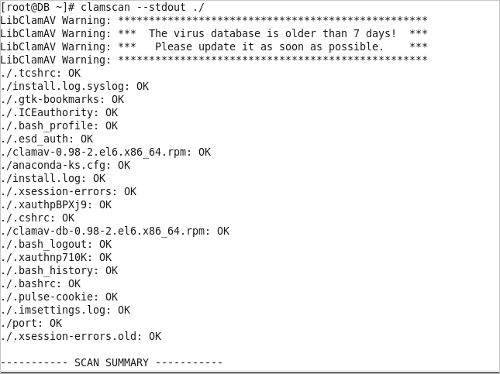

Firewall Configuration
The net connection will be prohibited except some specified IP.
The configuration as follow:：
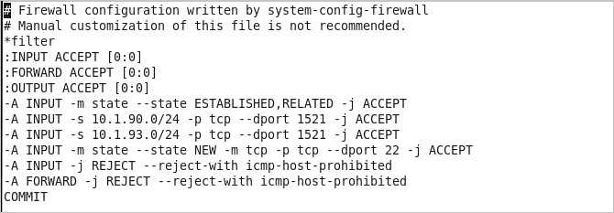
Start the firewall：(root)
chkconfig iptables on
service iptables start

Online Safety Processing

Log Processing

Remove the redundant log for printing
- Remove the key info.

- Remove the password info of database.

- Remove the MAC data（including the entire card number）
Sample: In the file channel\channel_pub\OSWApp.cpp：
// InfoLog("the final mac string is %s ", l_oStrMacData.c_str());
InfoLog("the final mac is %s ",l_acMacBuf);

- Remove the Net data（including card number, card track info and PINBLOCK info）
Sample: the function vWriteNetLog in the file channel\channel_pub\OSWSocket.cpp：
InfoLog("The Actual Length of %s: [%d]", p_pcDesc, p_iLen);
// InfoHexLogI(l_acData, l_DataLen, p_pcDesc);

- Remove SQL log
Sample: in the file channel\isopos\OCasDB.cpp：
#define EXEC_SQL_RETURN( l_acSql ) \
{\
//printf("[%s|%d|%s]SQL=[%s]\n",__FILE__,__LINE__,__FUNCTION__,l_acSql);\
// PrintMsg("SQL:[%s]", l_acSql);\
if( (l_iRet_Default = m_oDB.iExecSQL(l_acSql) ) < 0 ) \
{\
ErrorLog(ERR_DB_EXEC, "[sql=%s, errno=%d, errmsg=%s]", l_acSql, l_iRet_Default, m_oDB.pGetLastErrorStr());\
ERROR_RETURN(ERR_DB_EXEC);\
}\
l_iDsNum_Default = l_iRet_Default;\
}

Block the Safety Info
- Truncate the card number for printing
Truncate method：keep the First 6 and the Last 4，such as 622689******1111
if (strlen(p_psTxnLog->m_acPAN) > 10)
{
memset(p_psTxnLog->m_acPAN+6, '*', strlen(p_psTxnLog->m_acPAN)-10);
}

- Block the secret log info of External Domain for printing
Adding the following node in cfg/xml/isoatm for blocking domain in cpv.ptl(including 2, 35, 36, 48, 52, 55, 102, 103)
<log_mask_need>true</log_mask_need>

- Block the secret log info of internal domain for printing
Configure the blocked internal domain number in feel.ini:
[global]
#0 by termcode 1 by ip 2 termcode&ip
term_check_mode=0
#0 terminal connection is the only, 1 is not
conn_unique=1
#0:asc; 1:bin
mask_form=0
#log shield innertfield
inner_mask=22,34,55,56,68,72,75,80,81,122,123,124,182,183,193,199,200,202,229

The InterMsg::iGenLogMsg in app\parser\OFPParserTypes.cpp will processing as follow：
if (g_aiInterLogmask[i] == 1)
{
OFPStr l_oMask = "********";
if (i==22 || i==122 || i==123)
{
memset(l_acTmp, 0, sizeof(l_acTmp));
memcpy(l_acTmp, m_acData + m_aiOffset[i], m_aiFieldLen[i] > 2048?2048:m_aiFieldLen[i]);
if (strlen(l_acTmp) > 10)
{
memset(l_acTmp+6, '*', strlen(l_acTmp)-10);
l_oMask = l_acTmp;
}
}
l_sTmp.oFormatInput(" %-3d ",i);
p_rsLog += l_sTmp;
l_sTmp.oFormatInput(" %-20s ",g_acInterMsgName[i]);
p_rsLog += l_sTmp;
p_rsLog.append(l_oMask,l_oMask.size());
p_rsLog += "\n";
continue;
}

Audit Log Processing
Block or do not log down the confidential information for table T_TXNLOG、T_TXNLOG_H、T_VISATXNLOG、F005、PRE_TXNLOG、D012.
- Transaction Audit Log Table T_TXNLOG
Column  Table | C_PAN | C_TRACK2 | C_TFRINACC | C_TFROUTACC
T_TXNLOG/T_TXNLOG_H | Truncated | unsaved | Truncated Saved | Truncated

- VISA transaction table T_VISATXNLOG
Column  Table | C_PAN | C_TRACK2
T_VISATXNLOG | Truncated | unsaved

- POS transaction log table F005
Column  Table | CDNO
F005\F005H | Truncated

- Reversal transaction table PRE_TXNLOG
Column  Table | C_PAN | C_TRACK2 | C_DESTACC | C_TFRDEST
PRE_TXNLOG | Truncated | unsaved | Truncated | Truncated

- WEB Operation audit and card issue transaction audit table D012
Column  Table | CLNM
D012/D012H | Encrypted for card num

Encrypt Database Password
The database user and password will be software-encrypted with 3DES. The encryption step as follow：
Step 1：Encrypt user and password with feeltool.
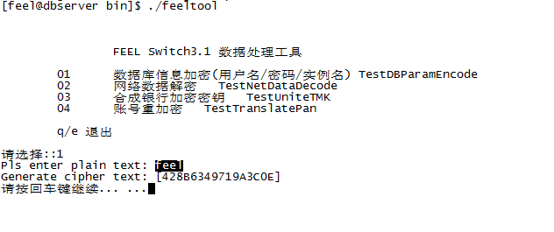
Step2：Configure feel.ini
[db]
db=1
dns=428B6349719A3C0E
user=428B6349719A3C0E
password=428B6349719A3C0E

Step 3：Decrypt user and password when connecting database. Modify the iConnectDB function in the ODBBase.cpp，as follow：
int ODBBase::iConnectDB(char *p_pcName ,int p_iType, char *p_pcPW , char* p_pcDNS)
{
int l_iRc;
string l_sErrMsg;
OSafety l_oSafe;
char l_acPlainUser[20]={0};
char l_acPlainPW[20]={0};
char l_acPlainDNS[20]={0};

l_oSafe.iDecodeDBParam(p_pcName, l_acPlainUser);
l_oSafe.iDecodeDBParam(p_pcPW, l_acPlainPW);
l_oSafe.iDecodeDBParam(p_pcDNS, l_acPlainDNS);

l_iRc = m_oDB.iDBOpen(l_acPlainUser, p_iType, l_acPlainPW, l_acPlainDNS);
if (l_iRc == 0) {
m_bIsDbOpen = true;
}

return l_iRc;
}

Clean Log and Backup-Data
Use the crontab for cleaning task，executing shell as follow:
#################################################
#Help as follow:
#baklog.sh
#crontab -l
#crontab -e
#1 1 * * * sh /home/feel/crontab/clearlog.sh
#
#crontab：
#crontab check，edit，restart，stop，start
#crontab -[l,e]
#service restart, stop, start
#service crond [restart,stop,start]
#################################################
1 1 * * * sh /home/feel/Online/crontab/clearlog.sh
1 1 * * * sh /home/feel/Online/crontab/bakdatabase.sh

Log Blocking Tool
This tool is use for blocking the lower version log info(including file and database) when the transaction system upgrade from lower version to higher version.

Log File Erase Tool—processLog
This tool is use to delete all log file in the specified directory. The instruction as follow:
Parameter 1：the specified directory where the log file saved
./processLog /home/feel/Online/cmsti

DB Audit Log Blocking Tool—processDB
This tool is use to delete some specified value of some column of specified table. The instruction as follow:
Parameter 1：Column
Parameter 2：Table
echo "start to process table t_txnlog:"
./processDB c_pan t_txnlog
echo "end of process table t_txnlog"

echo "start to process table t_txnlog_h:"
./processDB c_pan t_txnlog_h
echo "end of process table t_txnlog_h"

echo "start to process table pre_txnlog:"
./processDB c_pan pre_txnlog
echo "end of process table pre_txnlog"

echo "start to process table t_visatxnlog:"
./processDB c_pan t_visatxnlog
echo "end of process table t_visatxnlog"

WEB Safety Processing

Prohibit the SQL injection
- Adding the interface for prohibiting SQL injection：
//Collection interfaceInfos=(Collection)mysql.selectSql("select E021.* from E020,E021 where E020.USID='"+session.getAttribute("tsus").toString()+"' AND E020.CDTP='"+tree.toUpperCase()+"' AND E020.IIAC=E021.CDNO AND E020.CDTP=E021.CDTP");
The query sql will be change as follow (with the ? placeholder):
1． Collection interfaceInfos=(Collection)mysql.selectSql("select E021.* from E020,E021 where trim(E020.USID)=? AND trim(E020.CDTP)=? AND E020.IIAC=E021.CDNO AND E020.CDTP=E021.CDTP",session.getAttribute("tsus").toString(),tree.toUpperCase());

2．// mysql.getRowSql("SELECT IIAC,CUNM FROM E022 WHERE CDTP='"+temp.getCdtp()+"' AND CDNO='Card Types Table'");
mysql.getRowSql("SELECT IIAC,CUNM FROM E022 WHERE TRIM(CDTP)= ? AND TRIM(CDNO)='Card Types Table'",temp.getCdtp());
3 // mysql.getRow("P019","PMTP='"+tree.toUpperCase()+"' AND PMKY='Directory' AND PMCD='bin'");
Map<String, String> map = new HashMap<String, String>();
map.put("PMTP",tree.toUpperCase());
map.put("PMKY","Directory");
map.put("PMCD","bin");
mysql.getRow("P019",map);

4 //mysql.executeUpdate("insert into e009 values('"+obInterface.getString("c_termid")+"','"+e009temp.getString("i_txnid")+"','')");
The insert or update SQL should as follow:
mysql.executeUpdate("insert into e009 values(?,?)",obInterface.getString("c_termid"),e009temp.getString("i_txnid"));

the delete SQL as follow:
//mysql.delete("E009","TMID='"+obInterface.get("c_termid")+"'");
Map<String,String> map1 = new HashMap<String, String>();
map1.put("TMID",obInterface.get("c_termid").toString());
mysql.delete("E009",map1);

Forbid the Session Attack
1 Session ID prediction attack：
Adding the locking function when the password is wrong for 6 times:
if (obInterface.getInt("N_ERRCOUNT") > 6 && second < 5400) {
obInterface.setErmg(app.getString("error.LoginFail")
+ " : The user is locked");
System.out.println(" -------err count "+ obInterface.getInt("N_ERRCOUNT")+" second "+second);
obInterface.setUsst("F");
// obInterface.set("USST","F");
obInterface.setErcd("error");
mysql.update("P007");
throw new Exception("error");
}
if (!des.base64enc(tspw).equals(obInterface.getUspw())) {
System.out.println(" -password error errnum ++ ");
//log down the operation time
obInterface.set("D_ERRDATE", app.getCurTime14Str());
log.writeLog("********"+ obInterface.getString("D_ERRDATE") + "==========");
// mysql.update("P007");
int errnum = obInterface.getInt("N_ERRCOUNT");
++errnum;
obInterface.set("N_ERRCOUNT", errnum);
mysql.update("P007");
// log.writeLog("********"+obInterface.getInt("N_ERRCOUNT")+"==========");

//write by whxing end
obInterface.setErmg(app.getString("error.LoginFail")
+ " : "
+ app.getString("error.InvalidUserIDPassword"));
obInterface.setErcd("error");
throw new Exception("error");
}
Establish secure connection with HTTPS，setting the Session lifecycle and activated time
Server.xml
<Connector URIEncoding="UTF-8" compression="off" connectionTimeout="15000" maxThreads="150" port="8081" protocol="HTTP/1.1" redirectPort="8443" useBodyEncodingForURI="true"/>
Modify the timeout to 15mins

Adding the white-list in web.xml as follow:
<context-param>
<param-name>vas-url</param-name>
<param-value>D:\console\tomcat6\conf\Whitelist.txt</param-value>
</context-param>
The redirect page will configurated in Whitelist.txt

The implementation in loader.jsp
try{
if(request.getQueryString()!=null && request.getQueryString().length()>0)
{
String Route = request.getQueryString();
String [] ContainRoute =app.getWhitelist(request.getSession().getServletContext());
int i=0;
int start = Route.indexOf("/");
int end = Route.indexOf("?");
System.out.println(start+"end======"+end);
String Routename = new String();
if(end != -1)
Routename = Route.substring(start+1,end);

else
Routename = Route.substring(start+1,Route.length());
System.out.println(Routename);
while(!ContainRoute[i].equals(null)){
if(ContainRoute[i].equals(Routename))
{
%>
setopacity(50);
<%out.print("location.href='"+request.getQueryString()+"'");
break;
}
i++;
if(ContainRoute[i]==null) break;
}
if(ContainRoute[i]==null)
{
out.print("alert('The system cannot jump out of external links, please understanding ');");
out.print("location.href='/emapp/console.jsp'");
}
}

Prohibit Cross Site Script(XSS) Attack
Adding the special char filter in the web.xml as follow
<filter>
<filter-name>CharacterFilter</filter-name>
<filter-class>
ccas.CharacterFilter
</filter-class>
<init-param>
<param-name>characterParams</param-name>
<param-value>\\,#,^,~,`,&quot;,&gt;,--,!--,-&gt;,javascript,script,var,while,</param-value> <!—Adding the filtering char with comma splitting -->
</init-param>
</filter>
<filter-mapping>
<filter-name>CharacterFilter</filter-name>
<url-pattern>/*</url-pattern>
</filter-mapping>

Adding Validation Code
Configure web.xml as follow:
<servlet>
<servlet-name>ValidateCodeServlet</servlet-name>
<servlet-class>ccas.ValidateCodeServlet</servlet-class>
<init-param>
<param-name>width</param-name>
<param-value>200</param-value>
</init-param>
<init-param>
<param-name>height</param-name>
<param-value>80</param-value>
</init-param>
<init-param>
<param-name>codeCount</param-name>
<param-value>3</param-value>
</init-param>
</servlet>

<servlet-mapping>
<servlet-name>ValidateCodeServlet</servlet-name>
<url-pattern>/emapp/validateCodeServlet</url-pattern>
</servlet-mapping>

The validation code will be generated and validated in ValidateCodeServlet.java
How to use:
The validation for login：
String alidateCode = (String) session.getAttribute("validateCode");
String confirmAlidateCode = request.getParameter("logimag");

if (confirmAlidateCode == null || "".equals(confirmAlidateCode)) {
log.writeLog("verification code Error !");
session.setAttribute("ermg", "verification code Error!");
obInterface.setErmg(app.getString("error.LoginFail")
+ " : SafeCode error");
obInterface.setErcd("error");

response.sendRedirect("LoginSignon.jsp");
return;
}
String alidateCodeUpper = alidateCode.toUpperCase();
String confirmAlidateCodeUpper = confirmAlidateCode.toUpperCase();
if (!alidateCodeUpper.equals(confirmAlidateCodeUpper)) {
log.writeLog("verification code Error!");
session.setAttribute("ermg", " verification code Error!");
obInterface.setErmg(app.getString("error.LoginFail")
+ " : SafeCode error");
obInterface.setErcd("error");

response.sendRedirect("LoginSignon.jsp");
return;
}

Adding the validation code in common page:
<TD class=LoginHeader align="right">
<img SRC="<%=request.getContextPath()%>/emapp/validateCodeServlet?tempNum=" onclick="this.src=this.src+Math.random();" height="20" width='70' />
</TD>
<TD>
<INPUT class='TextField' type="text" id='safecode' name='safecode' size="5" maxlength="5">
</TD>
<td colspan="4" class="textRight">
Call the checkValidationCode function when post the form
function checkMyForm(){
if(!checkValidationCode('safecode')){
return false;
}

User Restriction Processing
New feature:
- The password error times will be forbidden
- The password will expire every 90 days
- The new password must not the same with the previous four
- Password must be composed of alpha a~zA~Z and number，and can not contain the user name
The main data will save in P007
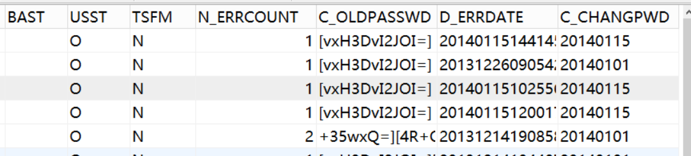

Encrypt DB User Name and Password for Tomcat
The configuration for Context.xml:
<Resource name="jdbc/mydb" auth="Container" type="javax.sql.DataSource" proxool.driver-class="oracle.jdbc.driver.OracleDriver" factory="emappDataSource.DataSourceImpl" proxool.alias="hrs" user="feel" password="50F92C854FB1DB3E" delegateProperties="foo=bar" proxool.maximum-connection-count="30" minimum-connection-count="5" proxool.maximum-active-time="10000" proxool.prototype-count="6" proxool.house-keeping-sleep-time="180000" proxool.house-keeping-test-sql="Select Sysdate From dual" proxool.driver-url="jdbc:oracle:thin:@10.1.90.133:1521:feel" />

The Algorithm for Password was implemented in emappDataSource/DataSourceImpl.java main ：
public static void main() {
Des odes = new Des("31323334353637383132333435363738");
String password = odes.enc("feel");
// System.out.println(" password "+password);
// System.out.println("DesDecode "+DesDecode(password));
}

HTTPS Configuration
Work with HTTPS server side certification(one-way)
Use the keytool to generate certification file：
keytool -genkey -alias tomcat -keyalg RSA -keysize 2048 -validity 3650 -keystore tomcat.keystore

[feel@dbserver:~/src]$keytool -genkey -alias tomcat -keyalg RSA -keysize 2048 -validity 3650 -keystore tomcat.keystore
Enter keystore password:
Re-enter new password:
What is your first and last name?
[Unknown]: 10.1.93.195 (Must be the domain name or server IP )
What is the name of your organizational unit?
[Unknown]: GRGBanking
What is the name of your organization?
[Unknown]: GRGBanking
What is the name of your City or Locality?
[Unknown]: GZ
What is the name of your State or Province?
[Unknown]: GD
What is the two-letter country code for this unit?
[Unknown]: CN
Is CN=10.1.93.195, OU=GRGBanking, O=GRGBanking, L=GZ, ST=GD, C=CN correct?
[no]: Y

Copy the tomcat.keystore to TOMCAT/conf
Modify the Connector port section in the server.xml as follow:
<Connector port="8443" protocol="HTTP/1.1" SSLEnabled="true"
maxThreads="150" scheme="https" secure="true"
clientAuth="false" sslProtocol="TLS"
keystoreFile="conf/tomcat.keystore"
keystorePass="changeit"
/>

Configure the secure page(the url-pattern) in web.xml as follow:
<security-constraint>
<web-resource-collection >
<web-resource-name >SSL</web-resource-name>
<url-pattern>/*</url-pattern>
</web-resource-collection>
<user-data-constraint>
<transport-guarantee>CONFIDENTIAL</transport-guarantee>
</user-data-constraint>
</security-constraint>

Log Safety Processing
Delete the information that contain ‘PANPAN’ from the log

Card Issue System Safety Processing

Card Issue Safety Processing on WEB Side

The password of Card will be hardware-encrypted with 3DES
//String random4=((int)(Math.random()*9000)+1000)+"";
//obInterface.setAtpw(random4);
//modify the pwd the whole 6 number
//obInterface.setAtpw(rs.randomNumeric(6));
String pas = rs.randomSixNumber();
obInterface.setAtpw(pas);
System.out.println(" obInterface. "+obInterface.getAtpw());
if (obInterface.getCvc2().length()>2) obInterface.setCvc2(App.getPVV(obInterface.getCdno(1),obInterface.getAtpw(),PVKIndex,PVKA,PVKB));
String l_Tspw = App.getPINBlokForHSM(obInterface.getAtpw(),obInterface.getCdno(1));

It is implemented in public static String getPINBlokForHSM(String p_PIN, String p_pan)

The card number will be hardware-encrypted with 3DES
The encryption interface for card number
obInterface.setCdno(obInterface.getCdno(),1);
The decryption interface for card number
value="<%=obInterface.getCdno(1)%>" size="20">&nbsp;

Online Side Processing

Card Number Encryption Tool—feeltool
The card number need to be encrypted in following table : E023、V001、V002、F001、F002
Step 1：Update the encryption key，the operation as follow:
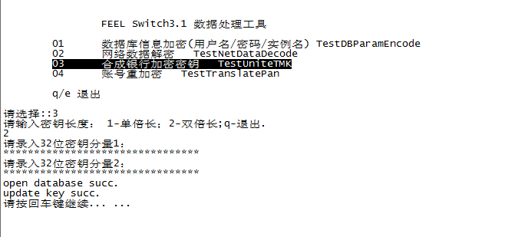

Step 2：Encrypt the card number with the new key，and save the encrypted number in the table，as follow：
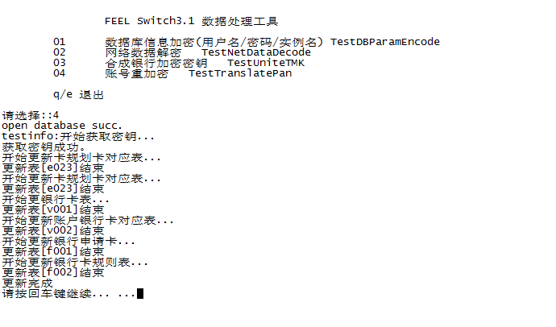

Card Password Encryption Tool—racaltool
Step 1：Update encryption key，as follow:
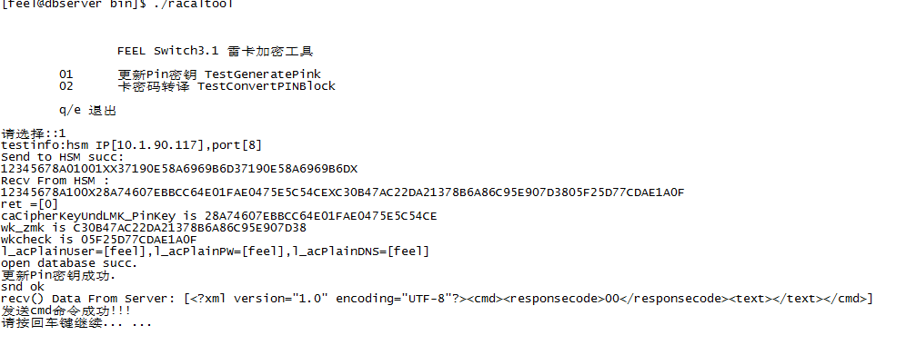

Step 2：Encrypt the card password with the new key，and save the encrypted password in the table，as follow:
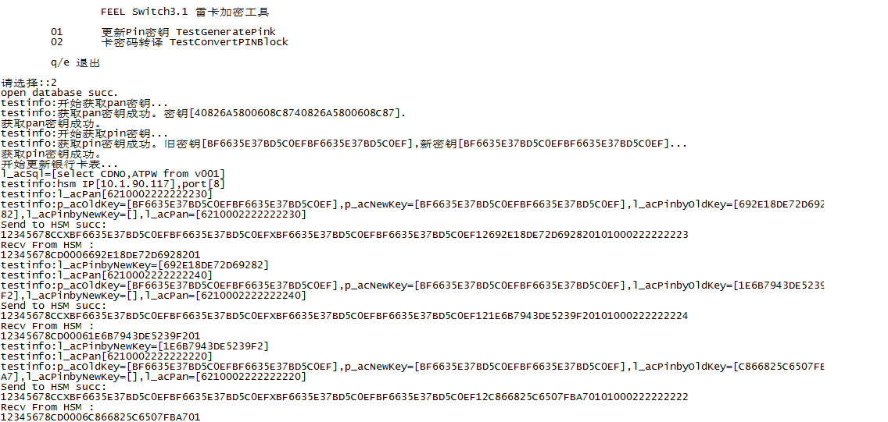

Card Issue Transaction Safety Processing
In the Card Issue system, the card number is encrypted and saved in the database.
It will be needed to encrypt the card number when the card issue transaction is processing. And the processing code as follow:
Step 1： Encrypt the card number:
The OCMSTxnFun::iRequest2Cms of app\project\swctrl\OCmsTran.cpp will processing as follow:
char l_acPanKey[100]={0};
if (l_pCmsDb->iGetPanKey(l_acPanKey) != CMS_SUCCESS)
{
throw OException(ERR_CMS_SYSTEM, "");
}
char l_acPan[100]={0};
char l_acPanEnc[100]={0};
int l_iPanEnc = sizeof(l_acPanEnc);
OSafety l_oSafe;
iGetInterMsgField(m_pShmMang, l_pSrvMsg->m_iSeq, 22, l_acPan, sizeof(l_acPan));
l_oSafe.iEncodePan(l_acPan, strlen(l_acPan), l_acPanEnc, l_iPanEnc, l_acPanKey);
iSetInterMsgField(m_pShmMang, l_pSrvMsg->m_iSeq, 222, l_acPanEnc, l_iPanEnc, true);

memset(l_acPan, 0, sizeof(l_acPan));
memset(l_acPanEnc, 0, sizeof(l_acPanEnc));
iGetInterMsgField(m_pShmMang, l_pSrvMsg->m_iSeq, 123, l_acPan, sizeof(l_acPan));
l_oSafe.iEncodePan(l_acPan, strlen(l_acPan), l_acPanEnc, l_iPanEnc, l_acPanKey);
iSetInterMsgField(m_pShmMang, l_pSrvMsg->m_iSeq, 223, l_acPanEnc, l_iPanEnc, true);

Step 2：Decrypt the card number when retrieving the card type
The OCmsDB::iGetCardType() of app\project\swctrl\OCmsDB.cpp will processing as follow:
char l_acPanKey[100]={0};
if (iGetPanKey(l_acPanKey) != CMS_SUCCESS)
{
return ERR_CMS_NO_INVALID;
}
char l_acPan[100]={0};
int l_iPanLen=sizeof(l_acPan);
OSafety l_oSafe;
l_oSafe.iDecodePan(m_vycom.CDNO, strlen(m_vycom.CDNO), l_acPan, l_iPanLen, l_acPanKey);
memcpy( l_acOTCD, l_acPan, l_iBinLen);

